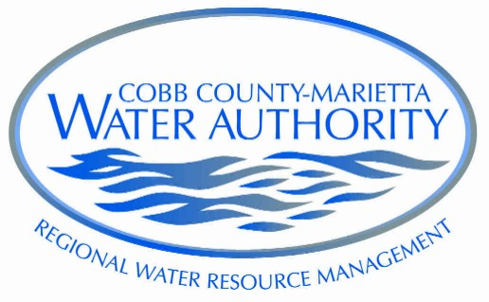
James A. Balli, Member
Michael H. Boyce, Member
Griffin “Grif” L. Chalfant, Jr., Member
Glenn M. Page, P. E., General Manager

James C. Scott, Jr., Chair
T. Daniel Buyers, Vice Chair
Charlie N. Crowder, Secretary
A. Max Bacon, Member

COBB COUNTY-MARIETTA WATER AUTHORITY

Agenda

Monday, May 18 --- 2:30 p.m.

- Invocation and Pledge of Allegiance
- Approval of Minutes of Regular Meeting of March 16, 2020 *
- Financial report *
- 2019 Auditor’s Discussion and Analysis **
- 2019 Mauldin & Jenkins Management Letter **
- Quarterly Investment Review **
- Pension Committee Report **
- Bid Results – Blackjack Mountain Pipeline Replacement Project
- On-Call Electrical Services Contract *
- Reschedule June Board meeting
- Old business
- General Manager’s report *
- New business
- Executive Session
- Legal *

*Attachment

** Included in package sent in April

Present: Max Bacon
James Balli
Mike Boyce
Dan Buyers
Grif Chalfant
Charlie Crowder
James Scott

